Project Planning Phase
Project Planning Logic
(Product Backlog, Sprint Planning, Stories, Story points)

Date | 13 February 2026
Team ID | LTVIP2026TMIDS34601
Project Name | TransLingua
Maximum Marks | 5 Marks

A Sprint fixed period or duration in which a team works to complete a set of tasks
An Epic is a big task or project that is too large to complete in one sprint. It is broken down into smaller tasks (stories) that can be completed over multiple sprints.
A Story is a small task . It is part of an Epic.
A Story Point is a number that represents how much effort a story takes to complete. (usually in form of Fibonacci series)
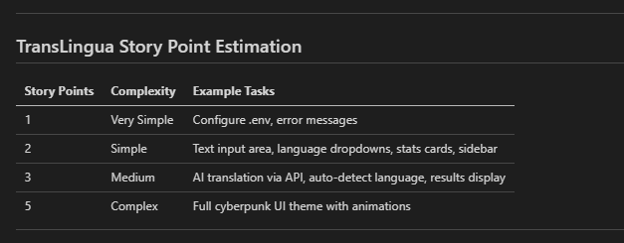

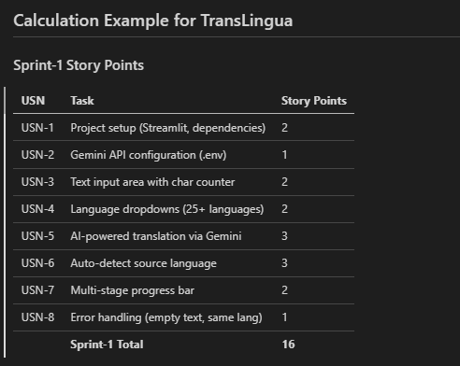

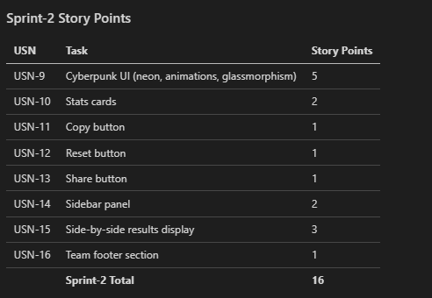

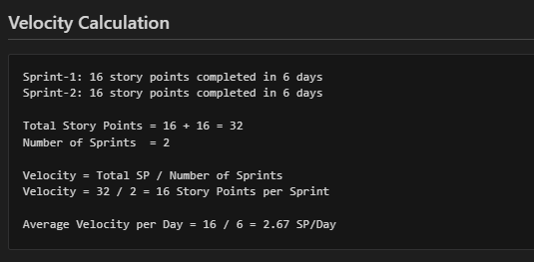

Team Velocity: 16 Story Points per Sprint

